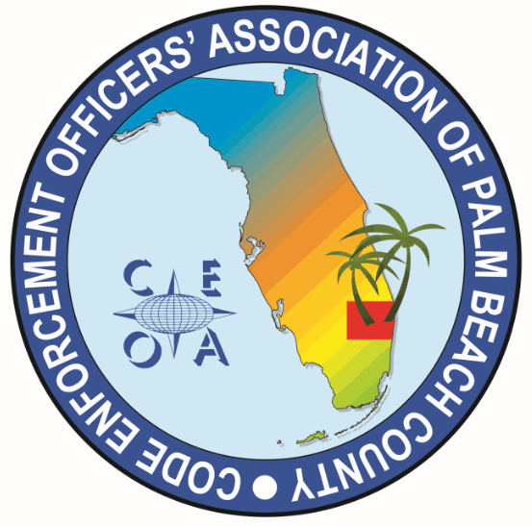
CODE ENNFORCEMENT OFFICERS ASSOCITION OF PALM BEACH COUNTY
MEETING AGENDA
THURSDAY, JUNE 4, 2026
8:30 AM
VIA ZOOM

CALL MEETING TO ORDER, ROLL CALL, ESTABLISH A QOURUM

NEW BUSINESS

- CONSIDERATION OF APPROVING UP TO $200 DOLLARS FOR WELCOME BAG ITEMS AT THE F.A.C.E. CONFRENCE AND UP TO $300 FOR DOOR PRIZES (GIFT CARDS) AT THE F.A.C.E CONFRENCE

ADJOURNMENT

